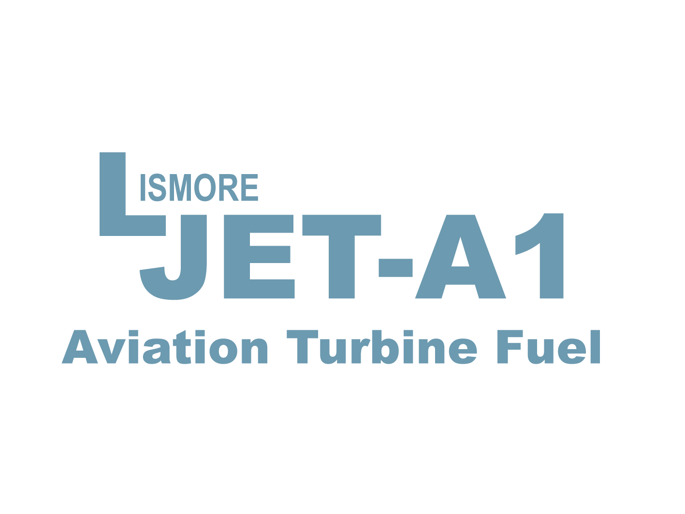
1 June 2013
Owners & Operators of Jet Turbine powered Aircraft.

Fuel Ordering Procedures for JetA1 at Lismore Airport YLIS

Due to the low volume of Jet Fuel required from Lismore Airport, it is not viable to have a refueler on site at the airport. However JetA1 is available 24 hours a day 7 days a week with a minimum one hour prior notice. A minimum hour’s notice is required so a refueler can be located and dispatched to the airport to have all product quality control and equipment inspections completed so to be in position for your scheduled arrival.
Placing an order for JetA1:
Voice Call only on 02 6622 8806 or 04 2244 1277
Alternate only If unreachable on above numbers - 04 0434 3043 (Michael)

Please Note: Due to system limitations ‘text messages’ do not divert and may not be received at the operations office.
To ensure your fuel order is correctly received, please speak to an operator or leave a clear and precise voice message.

Requirements 1 Hour Notice Minimum
When placing an order please provide Company name, aircraft type, registered tail ID and a reasonably accurate estimation of arrival time and parking intentions. (GA, North Apron) or (South Apron).
Important: Also specify payment type eg. Carnet Card type.

Lismore JetA1 Agent for Also accept

(Only with prior arrangements)
Cancelling a fuel order
If fuel is no longer required for any reason, you will be required to contact us before an operator has been dispatched to meet your aircraft. (See Fees & Charges).

Delays: ** Please contact us if possible with an amended arrival time if your aircraft has been delayed on its departure or is likely to be delayed en route.

Fees & Charges Invoiced to Registered Operator
Published operational hours are between: 0500 - 1700 Local Time
Services required outside these hours and on public holidays will attract a ‘Call Out’ Fee

$ 150.00 + GST June 1 2013 $165.00 inc GST * Discounts apply to Operational Medical Aircraft

A ‘Call Out’ Fee will also issued for the following reasons
- When fuel is ordered with less than the required minimum notice.
- Failure to cancel a fuel order less than 1 hour prior to the intended arrival.
** Delayed arrivals exceeding 40 mins may also incur a fee at operator’s discretion.

Thank you for your co-operation and support
Sincerely,

Michael Lindsay
Owner Operator
Lismore Jet-A1

